CURRICULUM VITAE

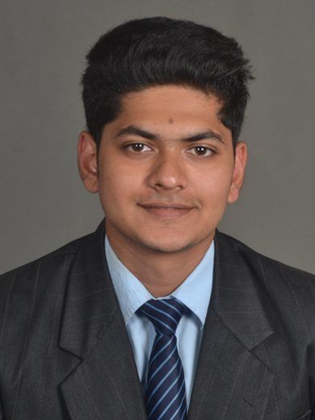

**_____________________________________________________________________**

**Name:** **Abhinav Borker**

**Address:** H No 206 Deulwada Borim Ponda Goa

**Contact Details:** 8806523445

borker.abhinav.abhinav@gmail.com

**________________________________________________________________________________**

**­­­­**

**Career Objective**

To excel in my field through hard workand earn a job which provides me job satisfaction and self development and to gain more knowledge.

**Experience:-**

06th July 2015 **Grand Hyatt Goa**

Till date (Front Office - as a Guest Service Officer)

**1ST April 2011 Hotel Nanutel** Margao Goa

**To 1st May 2011** Responsibilities (trainee)

● Food & Beverage Service

**20th December 2012 WOODBOURNE RESORT**, GOA

**To 26th December, 2012** Responsibilities (trainee)

● Food and Beverage service

Learnt about services

Handling Banquet Party

Learnt about Safety & security Standards of the Hotel

**Industrial Training (4TH June 2013** -- **JW MARRIOTT** Mumbai

**TO 4TH November 2013)** Front Office

Culinary

Housekeeping

Food and beverage service

**ODC’s** **Park Hyatt Goa**

**________________________________________________________________________________**

**Education Qualification:-**

* B. Sc. in Hotel Management (Y. C. M. O. U.)

Institute Of Advanced Management. Goa, India

(June 2012-2015)

* Gauncar higher secondary school (HSSC Goa Board )

(March 2012)

* MIBK High School (SSC Goa Board)

March 2010

**Interest and activities**

* Going out for a ride or a drive in spare time.
* Listening to music
* Social networking
* Playing cricket
* Dance

**Personal strengths:-**

* **Technical Skills**:-Basic knowledge of Microsoft office application
* **Personal Skills:**-Good communication skills and co-ordination skills

|  |  |  |  |  |
| --- | --- | --- | --- | --- |
| Languages Known | | Write | Speak | Read |
| English | |  |  |  |
| Hindi | |  |  |  |
| Konkani | |  |  |  |
| Marathi |  | |  |  |

**Personal Data :-**

* Nationality: Indian
* D.O.B. 11th March 1994
* Sex: Male
* Father Name : Mr.Ulhas Borker

**Reference:-**

Mr. Sandeep Sinha

Front Office Manager

Grand Hyatt Muscat

Sandeep.sinha@hyatt.com

Mr. Gaurav Lad

Assistant Manager Front Office

Grand Hyatt Goa

Gaurav.lad@hyatt.com

-----------------------------------------------------

Abhinav Ulhas Borker.